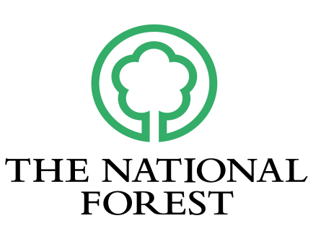
National Forest Company
Creative Commission – Culture & Cycling
Application Form
Please complete this form fully, using additional sheets where necessary.

Applicant Details

Name
Address

Email

Telephone

Are you based in the Midlands? Yes No (this opportunity is for Midland’s artists/creatives)

Do you have evidence of a current DBS check? Yes No

Experience
Please provide some brief details about your interest in this commission and your experience of delivering similar projects (up to 800 words).

Details of proposal
Proposal: Describe the creative project that you are proposing, including the activities and outcomes you intend to develop. Please consider the aims outlined in the brief and the schedule provided (up to 800 words).

Engagement: Please provide details about who the project will engage and how you will ensure activity is accessible and inclusive. (up to 250 words).

Environmental Responsibility: Describe how you will take a sustainable, low carbon approach to the commission (up to 250 words).

Risks: Please include any information about measures that you will put in place to safely deliver this activity (up to 250 words).

Budget
Outline all proposed costs involved in the delivery of your project including fees, materials, production and travel.
NB A maximum of £5000 is available for the commission. Up to 50% will be available at the beginning of the project to be allocated in Phase 1, up until 31 March. A further 40% will be available for Phase 2, from 1 April and the remaining 10% paid on completion of the project. Please see further information within the Artists’ Brief regarding budget and payments.
Item (up to 31 March 2026) | Cost (ex VAT) | VAT | Cost (inc VAT)
Item (between 1 April – 31 October 2026) | Cost (ex VAT) | VAT | Cost (inc VAT)
Total | £ | £ | £

Personal Access Costs
If you, or any of the project collaborators identify as D/deaf, Disabled or neurodivergent, experience learning difficulties, mental health conditions or long-term health conditions and have extra costs related to access needs, please include below, along with the expenditure amounts (up to a maximum of £1000).

Are you registered for VAT? Yes No

Declaration
To the best of my knowledge the information supplied with this application is correct.
Signed: |  | Date

Please include weblinks relevant to this application and/or an attachment with further details about your work (max 2 sides). Add the weblink and the title of any attachments below -
1:
2:
3:

The deadline for applying is 5pm Thursday 11 December 2025.

Please email your application to Jo Maker, titled ‘Culture & Cycling Commission’ - jmaker@nationalforest.org

If you have any queries about the application process that are not answered in the Artists Brief, please contact Jo Maker, Arts & Creativity Manager, jmaker@nationalforest.org or 07816 213225.

